Operations Manual for ultrasonic
SONOROD Generator

THE MPI2000 ULTRASONIC
SONOROD GENERATOR

ULTRASONIC GENERATOR – Manual

CONTENTS
INTRODUCTION 3
SAFETY INSTRUCTIONS 4
GENERAL VIEW AND DIMENSIONS/mm/ 6
INSTALLATION & ENVIRONMENT 7
Power supply 7
Connections on the back of the generator 8
Assignment of the 25-pin DSUB interface socket 9
Interface Description 13
OPERATION 16
Operator elements and display on the front panel 16
The LCD display 16
SETTING THE SOFTWARE 21
ADJUSTING THE GENERATOR USING THE PC SOFTWARE 22
COM Tab 22
“CONTROL” tab 24
“SCAN” tab 26
PROPERTIES tab. 27
OSCI tab. 29
WELDING Tab. 30
HF-DA RELAY MODE 33
ERROR MESSAGES AND TROUBLESHOOTING 34
MAINTENANCE 37
SPECIFICATIONS: 38
WARRANTY 39
SPARE PARTS 39

INTRODUCTION

Dear Customer,
Thank you for your purchase of the MPI2000 product.
This ultrasonic sonorod-generator has been developed using the latest technologies to allow for greater overall performance and stability.

Please read and follow these operating instructions carefully before installing or commissioning your product. As with any electrically powered device, failure to observe these instructions can present a risk to life.

The device may only be operated and maintained by personnel who have read and understood
this operating manual and are familiar with the applicable legal regulations for accident prevention and workplace safety. Failure to comply with this will result in a loss of warranty rights.

For ease of reading this operating manual, the MPI2000 may also be referred to by the terms ‘unit’ or ‘device’ interchangeably

SAFETY INSTRUCTIONS

Before starting up your device, please read through the following instructions carefully, both for your own safety and for the safety of the device.

Keep this manual where it can be readily accessed by all systems users.

Installation is to be carried out by qualified technical personnel only!

This ultrasonic generator is to be operated by properly trained personnel only!

Due to the way it operates, additional safety measures must be taken if the device is to be used in areas posing an explosion risk.

The electromagnetic compatibility corresponds to the standards and regulations listed in the specifications.

All necessary settings were either made in the factory or are described in this handbook.
However, should problems occur on start-up, please do not make any prohibited adjustments to the device, as this would endanger your warranty rights. If in doubt, please contact our technical service staff.

Please contact our technical service if at all in doubt. Please see the last page.

Inspection or diagnostic work inside the device may only be carried out to the extent described and, as with the electrical connection should only be performed by skilled personnel. When performing such work, the ultrasonic generator must be completely disconnected from the main power source. (unplug the mains connection).

The device must always be disconnected from the mains before cleaning or when installing/uninstalling an option. Do not use liquid cleaners or sprays. Only use a damp cloth.

Inputs or outputs that are used for controlling or monitoring purposes should be twisted and shielded.
The device must not be in close proximity to electrically charged components or cables.

The shielding should be connected to the generator‘s earth on one side of the generator.
Attention: All connections for the signal or control lines are galvanically connected to the generator.

Always observe any warnings or instructions provided on the device itself.

The platform for the device must be sufficiently stable, as the device being jolted or falling could cause severe damage.

Ensure that the power supply specifications given on the device are met.

Only those transducers which have the correct frequency, power output and dimensions may be used with this generator.

HF cables from the generator to the transducer as well as mains cables to the generator may not be rolled up if they are too long. Instead, they must be shortened to the required length due to the risk of overheating.

With the exception of the permitted tasks listed in the handbook, you should never attempt to repair or modify the device yourself.
In the following cases you should disconnect the device from the mains and contact a qualified service engineer:

· If the mains cable or plug is damaged
· If liquid has penetrated into the device
· If the device has fallen over or the housing is damaged
· If the device displays noticeably different behaviour than standard operation

ATTENTION: Repairs and modifications may only be carried out by competent, skilled personnel!

GENERAL VIEW AND DIMENSIONS/mm/

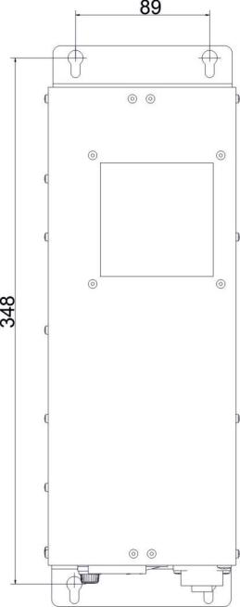

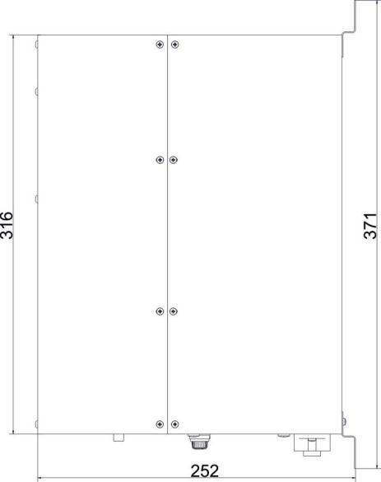

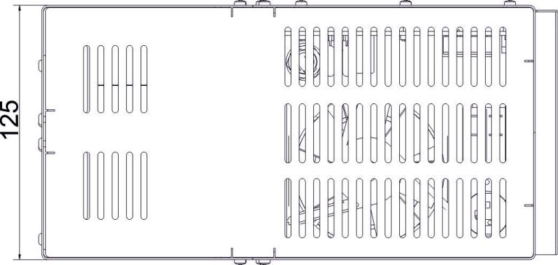

INSTALLATION & ENVIRONMENT
Choose a suitable location that will protect the device from moisture, water, excessive sunlight and heat.
The selected location for the device should be in an area where ambient temperatures do not exceed 40°C.
If the generator cannot dissipate the heat sufficiently, it will display an error message due to excess temperature (see also the “OVER TEMPERATURE” error description).
ATTENTION: • Choose a location that will prevent steam or any other aggressive
vapours from penetrating the device. Ambient temperatures of over 30°C should be avoided.
• Over a period of time, chemically contaminated ambient air can lead to
the device being irreparably damaged.

Power supply
The ultrasonic generator draws its power (210-250VAC/50-80Hz) via the connection cable with Power socket.

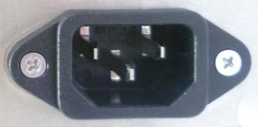
It has an external main fuse (10 AF).
ATTENTION:

- For safety reasons, always disconnect the unit from the mains before changing fuses.
- Plug racks into earthed sockets only.
- Always replace blown fuses with new fuses of the same type.
- This should only be performed by qualified, skilled personnel.

Connections on the back of the generator

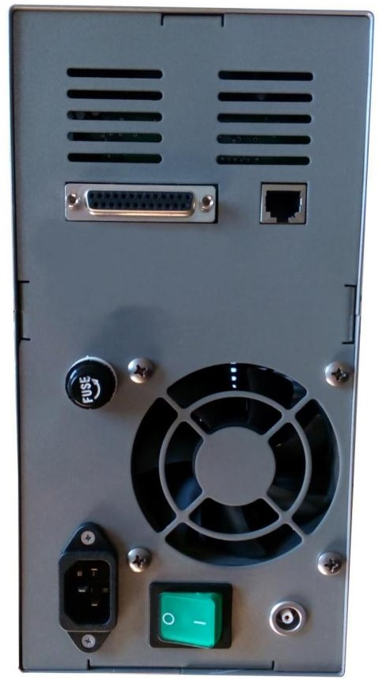
HF OUTPUT: HF Output connector is a Lemo : ERA.1S.250.CTL

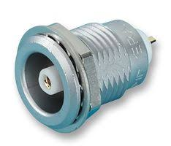
ATTENTION:
- Output voltage could be between 600V and 1200V AC.
- Only use cables specified by the manufacturer.
- Use only shielded transducer connection cables.
- Connect the shielding to the PE conductor on the generator side.
- Only use cables with sufficient cross-section.
- Minimum cross-section: 1.5 mm2.

Interface socket RS485 ModBus
RJ 45 CONNECTOR:

PINS | DESCRIPTION
1 | GND
2 | GND
3 | N/C
4 | A
5 | B
6 | N/C
7 | 12 V DC
8 | 12 V DC
25-pin DSUB I/O socket

Assignment of the 25-pin DSUB interface socket

PIN NO. ON DSUB SOCKET  INTERFACE X1 | SIGNAL NAME | DESCRIPTION
1 | +12 VOLT OUT | 12 Volt for external use
2 | POUT | Output 0 – 10 Volt = Power output 0 – 100 %
3 | P-EXT.-IN | Analog Input 0 – 10 Volt for power control
4 | GND | Shared reference point = Ground
5/9 | HF-DA-ERROR | Optrone root (shared) for “HF-DA” and “ERROR”
6 | HF-DA | Output “HF-DA”
7 | ERROR | Output “ERROR”
8 | A | A signal of RS 485 interface
9/5 | HF-DA-ERROR | Optrone root (shared) for “HF-DA” and “ERROR”
10 | B | B signal of RS 485 interface
11 | <> Nominal | Output for nominal value
12 | FAN-ON | Monitoring output = 12 Volt when the fan is running
13 | FS-24 V | Remote control input (with 12 – 24 Volt)
14 | GND | Shared reference point = Ground
15 | GND | Shared reference point = Ground
16 | N/C | Spare
17 | FAN-ON | Monitoring output = 12 Volt when the fan is running
18 | N/C | Spare
19 | N/C | Spare
20 | VCC +5V | Max 50 mA
21 | Clock | Digital Output Clock(SPI interface)
22 | Data Out | Digital Output Data Out(SPI interface)
23 | Letch | Digital Output Letch(SPI interface)
24 | Data_in | Serial Digital Input Data In(SPI interface)
25 | Direction | Digital Output Direction(SPI interface)

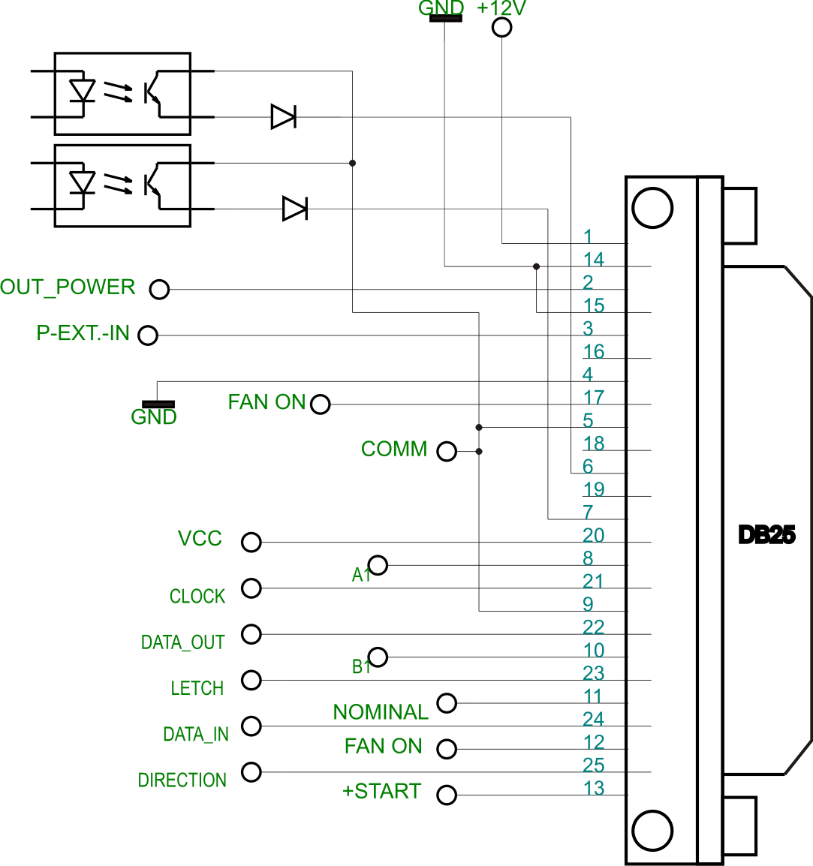

Picture shows internal schematic of generator.
Typical connection of generator:
- Manual control
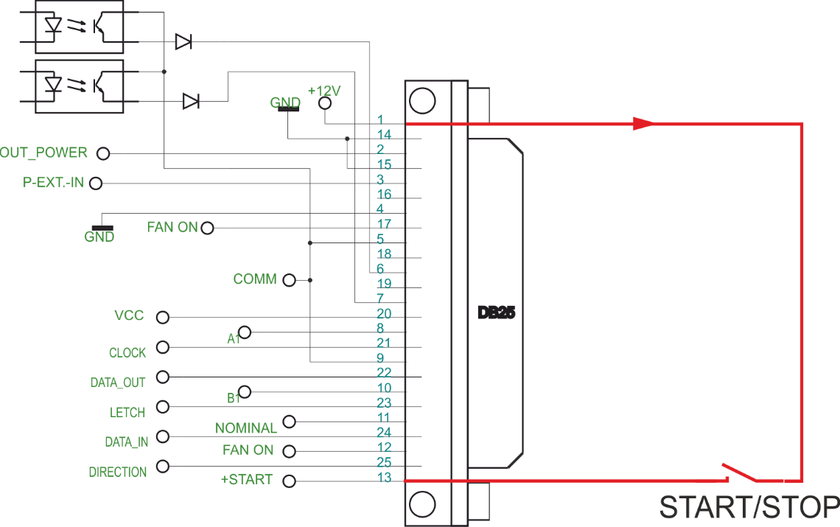
- PLC control

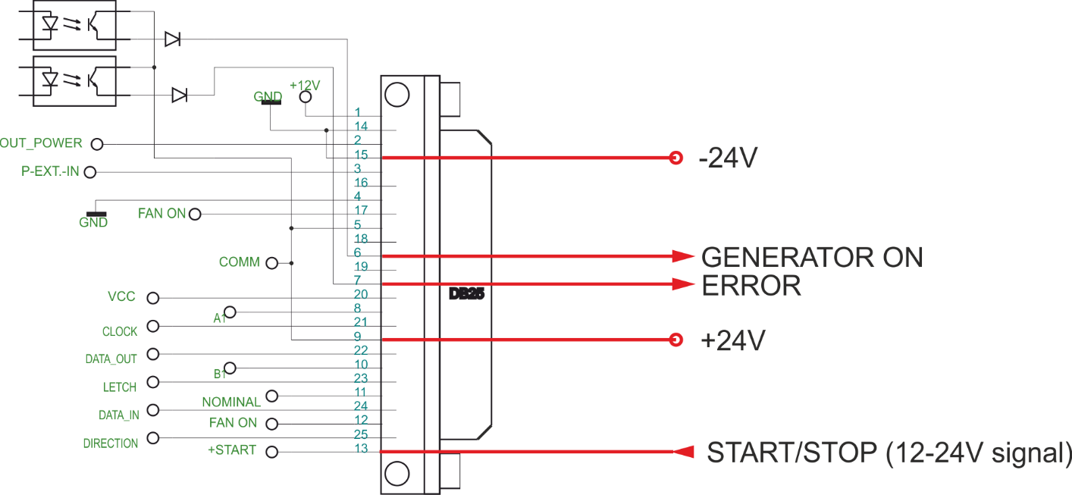

ATTENTION: A shielded control cable must always be used for the interface.

Interface Description

1.) Signal “+12 Volt Out” DSUB PIN 1
A voltage of 12 V is available at this output. This voltage can be loaded with max. 100 mA and can,
for example, be used to output a voltage for the function “HF-DA” and/or “Error”.

This voltage can also be used to switch on the generator on the input “FS-24 V”.
2.) Signal “POUT” DSUB PIN 2
At this output a voltage proportional to the power output of between 0 and 10 V
(= 0 – 100 % power output) is available.
Reference point = “GND”.

3.) Signal “P-EXT.-IN” DSUB PIN 3
By connecting a voltage between 0V and 10 V, the output of the generator can be set to between 0% and 100 % of its nominal amplitude or power. This is only possible when the value of parameter “ AMPLITUDE ” is set to 0 from the LCD or PC software.
Reference point = “GND”.

4.) Signal ”GND” DSUB PIN 4

5.) Signal “HF-DA ERROR” DSUB PIN 5/9
Shared in/output for the internal optocoupler “HF-DA” and “ERROR” (these PINs are connected internally).

6.) Signal “HF-DA” DSUB PIN 6
If the ultrasonic generator has been switched on via of the signals “FS-24 V”, “FS-GND”
and is emitting HF voltage (i.e. there is no malfunction), an internal optocoupler is
closed. (between PIN 6 and PIN 5/9)

The “root” of this optocouplers leads through to a PIN 5/9 (these pins are connected internally)
in the DSUB socket.
A voltage connected to Pin 5/9 can be switched through (max. 36 VDC / 20 mA).

7.) Signal “Error” DSUB PIN 7
This is the output of an internal optocoupler (root to PIN 5/9).

This optocoupler reports generator malfunctions. This means that if the generator is switched on and,
for some reason the power output does not correspond to the set level, this optrone is activated.

An external voltage connected to “HF-DA-Error” can, of course, also be switched through here (max. 36 VDC / 20 mA).

8.) Signal “A” DSUB PIN 8
A signal of RS 485 interface

10.) Signal “B” DSUB PIN 10
B signal of RS 485 interface

11.) Signal “<> Nominal” DSUB PIN 11
Internal use only.

12.) Signal “FAN-ON” DSUB PIN 12
At this output, there is a control voltage (12 Volt) for monitoring the fan
function when the internal fan is running.

13.) Signal “FS-24 Volt” DSUB PIN 13
Switching on the generator (Ultrasound On) by connecting a voltage between
12 – 24 Volt between PIN 13 and GND (PIN 4,14 or15).

14.) Signal “GND” DSUB PIN 14

15.) Signal “GND” DSUB PIN 15

17.) Signal “FAN-ON” DSUB PIN 17
At this output, there is a control voltage (12 Volt) for monitoring the fan
function when the internal fan is running.

!!!! INTERNAL USE ONLY:
20.) Signal “VCC +5V” DSUB PIN 20
+5V max 50mA
21.) Signal “CLOCK” DSUB PIN 21
Digital Output Clock(SPI interface)
22.) Signal “DATA OUT” DSUB PIN 22
Digital Output Data Out(SPI interface)
23.) Signal “LETCH” DSUB PIN 23
Digital Output Letch(SPI interface)
24.) Signal “DATA_IN” DSUB PIN 24
Serial Digital Input Data In(SPI interface)
25.) Signal “DIRECTION” DSUB PIN 25
Digital Output Direction(SPI interface)

OPERATION

Operator elements and display on the front panel
Button START/STOP
Button UP
Bicolour LED
Button MENU
Button DOWN
Bicolour LED: Lights up blue when generator is switched on and works properly
Lights up red in the event of an error
START/STOP button: The generator is switching on and off by pressing this button.
Button UP ▲ and Down ▼: For moving up and down to select parameter and between menu windows.
Button Menu ●: Multifunction button:
- By pressing the button MENU you can change current parameter.
- By press+hold for 5 seconds you will WRITE TO MEMORY all present settings of the generator.

The LCD display
1.Initializing window display:
After the generator is powered on, the initial screen contains the following status information.
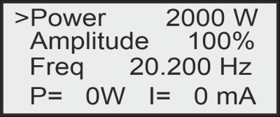
Power – setting for maximal power (in W)
Amplitude – setting for maximal amplitude (in % where 100% = 1000V)
Freq - Frequency – setting for starting frequency (in kHz) - it should be higher (I.e. 100Hz) than the working resonance frequency of the load and when generator starts - it shifts down towards the exact resonance frequency.
P – Actual Output Power Value (in Watts)
I – Actual Output current through the transducer (in mA)
2. Energy window
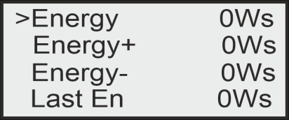
These are welding regime settings. Welding by energy:
Energy – setting of nominal energy during the welding process (in Ws). If the setting is different from 0 and the generator reaches the set value the Welding Time(see page 23-24) automatically stops.
Energy plus – maximum allowed energy reached during the welding process.(in Ws)
Energy minus – minimum allowed energy reached during the welding process (in Ws)
Note: If the energy during the welding process is out of limits Energy Plus and Energy Minus, the bicolour LED will light in red and an error message Limit Energy will be displayed.
Last Energy – energy of the last working cycle (in Ws)
3. System window
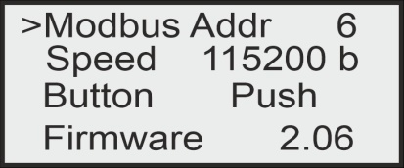
Modbus Address – shows the address of the generator in the Modbus network. The default Modbus Address is 6.
Speed – communication speed
Button – setting the functionality of the button
There are 4 options:
OFF – the button is off.
PUSH – the button works as a test button – while pushed the generator is on, while released the generator is stopped. See the picture below:
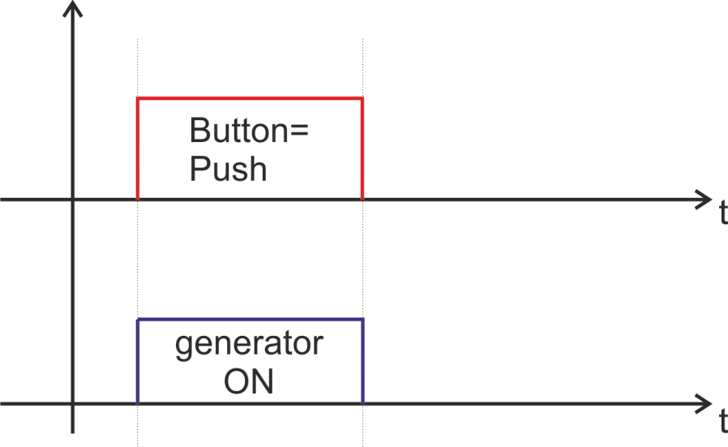
LATCH- pushing the button once the generator starts, pushing the button again the generator stops.
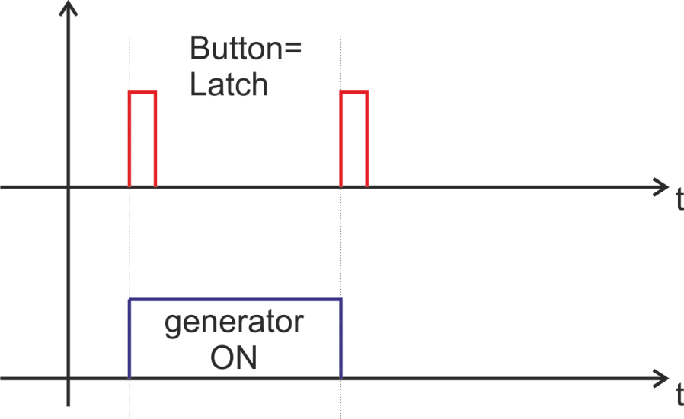

TRIGGER – pushing the button once the welding cycle starts.
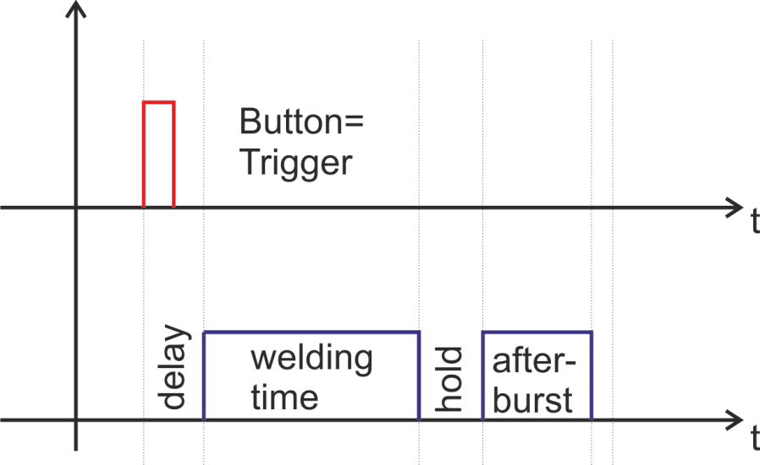
The generator could generate error signal, when the temperature is over the set limit.

4. Peak power window
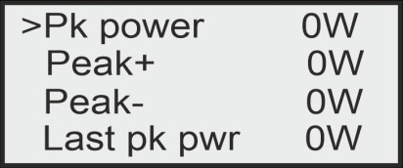
These are welding regime settings. Welding by peak power:
Peak Power – setting of the peak power (in W). If the setting is different from 0 and the generator reaches the set value of the peak power, the Welding Time(see page 23-24) automatically stops.
Peak plus – maximum allowed peak power reached during the welding process (in W)
Peak minus– minimum allowed peak power reached during the welding process (in W)
Note: If the Peak Power during the welding process is out of limits Peak Plus and Peak minus, the bicolour LED will light in red and an error message Limit Peak Power will be displayed.
Last pk Power – peak power of the last working process (in W)
5. Time window
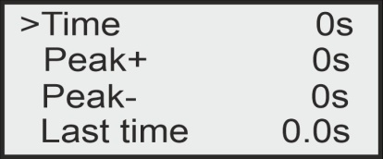
These are welding regime settings. Welding by time:
Time – time when the generator is on (in seconds)
Time plus – shows the maximum duration of the control signal (in seconds)
Time minus – minimum duration of the control signal (in seconds)
Note: If entered a control signal from external control unit (PLC) out of limits Time Plus and Time minus, the bicolour LED will light in red and an error message Limit Time will be displayed.
Last time - duration of the last working cycle (in seconds)
6. Delay, Hold and Afterbirst window
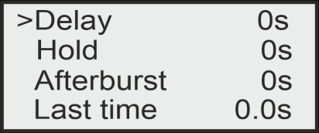
Delay – after the start signal, the generator delays starting with the set value of the delay (in seconds) (see page 23-24)
Hold – the generator delays with the set hold value before executing Afterburst (in seconds) (see page 23-24)
Afterburst – setting the value of afterburst (in seconds)
Last time - time for the last working process (in seconds)

7. LCD Tune window
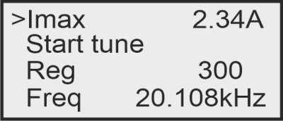
Imax – The output current by the set output power
Start tune – Starts the autotuning process by pressing the MENU● button of the display. Generator start scanning the load in the range (Freq +1/2 Span ) down to (Freq -1/2Span). If better starting frequency is found the Freq value will be replaced with new one, or else the Freq value will remain the same.
Reg – regulator value
Freq - Frequency – setting for starting frequency (in kHz) - it should be higher (I.e. 100Hz) than the working resonance frequency of the load and when generator starts - it shifts down towards the exact resonance frequency. By Start tune new or better starting frequency could be found. . If better starting frequency is found the Freq value will be replaced with new one, or else the Freq value will remain the same. The new value could be saved by Write to memory if desired.
8. Write to memory window
This window appears when you press AND HOLD the MENU button for 5 sec.

SETTING THE SOFTWARE
The generator has a standard communication interface ModBus RTU over RS 485. To connect to a PC you should use MPI adapter USB or RS 232 to RS 485 optically isolated.

Before starting the software for the generator, you need to follow and execute the following steps

Install the software in the sequence as follows:

1. LVRTE2012f3std - this is the Runtime Engine of National Instruments LabView2012

2. niser360f3 - drivers for serial communication ports of National Instruments LabView 2012

3. CDM v2.12.00 WHQL Certified - driver for USB to RS485 adapter using FTDI chip FT232RL - you can use she attached here file (for Windows), or download
the latest version, updated for your OS from here: https://www.ftdichip.com/Drivers/VCP.htm

Now you are ready to start the executable file, “sonoweld DDS.exe”, of the software of your generator.
- First action (regarding all generators and all software we are offering), after activating specific generator software, is to connect your PC with ultrasonic generator using our RS485-USB adapter.
- Then you need to select and activate proper operating COM port from the generator software tabs. This will open communication between your PC and your ultrasonic generator.
- Then you need to select initial setting conditions regarding expected frequency range.
- Then you need to make Scanning to see where ultrasonic load is able to operate.

ADJUSTING THE GENERATOR USING THE PC SOFTWARE

COM Tab
Start with COMM tab, and select proper COM port.
NOTE: Every new generator has 5 modbus address by default.
To connect the generator to the labview software we need to cover the following three conditions:
To know the Modbus address of the generator. Every new generator has 6 modbus address by default.
To know the exact COM port where the USB to RS485 driver is installed. Go to the Device Manager of your PC and find the USB Serial Port(The USB adapter must be plugged to one of the USB ports of your PC).
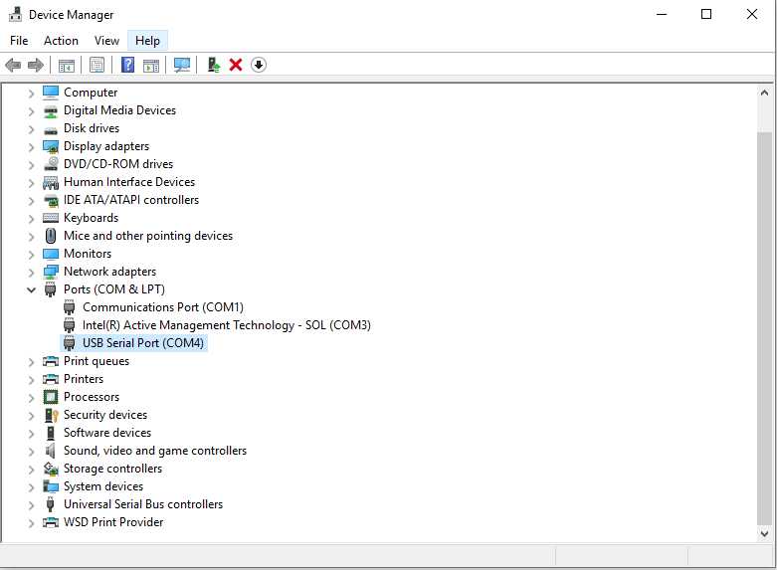

To set the correct communication baud rate.
At this moment you will have NO connection (initialized in red on top of the window)(2).
After validating the com port you will have connection (initialized in lime green on top of the window).

4. Select the ModBus address of the generator you want to connect to. Every new generator has default ModBus address 6.
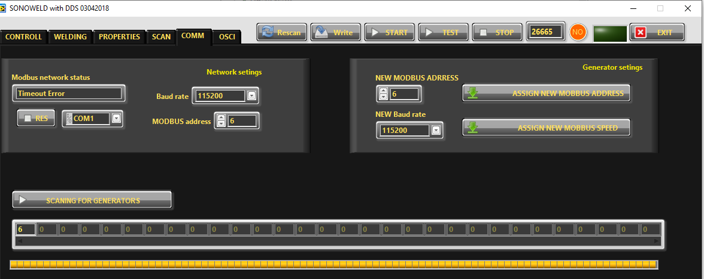
Press “SCANNING FOR GENERATORS”. After scanning (the yellow bar will become full in a few seconds), you will find the address (es) of the available generator(s) you will drive . Check if the value of the address in “MODBUS address” field is correct and if needed change it with the value shown in the table below the button “SCANNING FOR GENERATORS”. Beat counter will become alive and will start changing the figures. Connection (lime-green) light should be active. Now you are connected to the generator with the selected address.
NOTE: Every new generator has 6 ModBus address by default.
That’s why you have the possibility in the upper right side of the window to change the Modbus address selecting a new value in the field “NEW MODBUS ADDRESS” and then press the button ASSIGN NEW MODBUS ADDRESS.
DO NOT FORGET TO CHANGE THE MODBUS ADDRESS IN THE FIELD WITH THE NEW ASSIGNED MODBUS ADDRESS.
Save this setting in generator’s EEPROM Memory by pressing button WRITE (top centre of the window).

5. Select “Baud Rate”. The default value is 115 200 bauds/sec.
At this stage you could replace the ModBus address and the Baud Rate of the generator. This could be necessary in case you have more than one generator to adjust in the same network. The Baud Rate should be matched to the topology of your network.
The replacement is performed by pressing the button "Assign New ModBus Address" and / or button "Assign New Baud Rate".
The change is saved after pressing the button "WRITE" (top centre of the window).
6. If the generator is connected to the software, the indicator light CONNECTION glows green (YES).

Go to the first

“CONTROL” tab
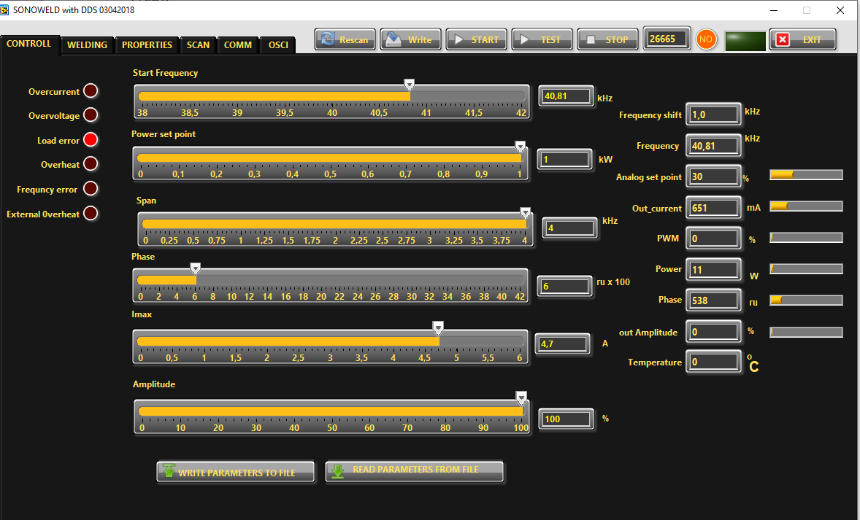

7. Go to CONTROLL Tab. The very first step is to press the button RESCAN to have all parameters and settings from the generator uploaded in Labview software.
8. In the slider Start Frequency set Start frequency.
9. If the transducer is 20 kHz choose for Fstart set a little bit higher of 20 -for example 20,5. Save this setting by pressing button WRITE (top centre of the window).
10. In “SPAN slider” set initially safety operation window 2 kHz, it means Span=2 kHz.
Buttons:
RESCAN – By pushing RESCAN all parameters saved in the generator’s memory will upload into Labview software.
WRITE - By pushing WRITE all parameters set in Labview software will download into the generator’s memory.
START - By pushing START the generator starts the welding cycle (see page 23).
STOP - By pushing STOP the generator stops working.
TEST - Button “TEST” will start the generator even the Time is selected 1sec. and will stop only when button “STOP” is pressed.
WRITE PARAMETERS TO FILE - WRITES all parameters set in Labview software into a text format(.txt) file on the hard disk of the computer.
READ PARAMETERS FROM FILE - READS all parameters from text format(.txt) file on the hard disk of the computer and downloads the data into the generator.

Sliders:
Start Frequency – sets the start frequency of the generator.
Power Set Point – sets the output power of the generator.
Span – sets the working window, where the generator seeks the working frequency of the transducer, because the working frequency could change because of loading the transducer and/or the temperature of the transducer.
Phase – The optimal phase is 2000. (in relative units x 100)
I max - This is the maximum allowed current over the transducer. You need to check the label on your transducer and set the value.
Amplitude – The actual voltage over the transducer (in % of the maximum allowed)
Actual Values:
Scan Shift – for service use only (in relative units)
Frequency Shift – shows (in kHz) how many the starting frequency is changed by the frequency regulator of the generator.
Frequency – shows (in kHz) the actual working frequency of the transducer.
Analog Set Point – shows(in Watts) the actual value of the analog power set point(0-10V) over the 25-pin connector(see page 10, pin3).
Out_current – shows (in mA) the output RMS current through the transducer.
PWM – shows (in %) PWM ratio over the gates of the power transistors.
Power – shows (in W) the actual output power.
Phase– shows (in ru=relative units) actual working phase.
Amplitude – The actual voltage over the transducer (in Volts)
Temperature – Voltage over pin 8 of the Interface connector, corresponding to the transducer temperature. Reference is GND. 0V=0°C; 10V=100°C (in °C)

Go to

“SCAN” tab
and activate SCAN.
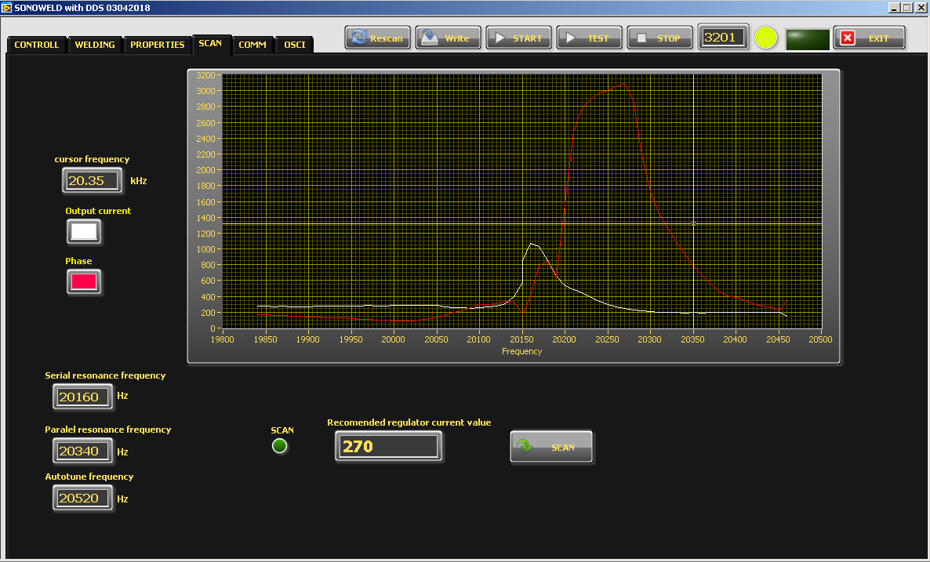
11. Press the SCAN button. The scanning procedure starts. There is a drawing consisting of phase characteristic (red line) and current characteristics (white line). It should be similar to the picture with well-defined phase feature. This diagram shows the actual operating parameters of the transducer. If necessary, pick new Fstart and SPAN (in CONTROL tab).
You will see an active operating area of transducers, like on the picture above. It starts a scanning procedure on low power that indicates the Phase characteristic (red line) and consumed output current (white line). For F-start in the CONTROL Tab you need to select, the value in the Autotune Frequency box(it is about 200 Hz higher than the parallel resonance frequency). Click the WRITE button on top of the window to write in generator’s memory all present settings.
12. In “POWER Set Point “ in CONTROL tab, set the desired value for maximum power, of your generator.

13. Go to

PROPERTIES tab.
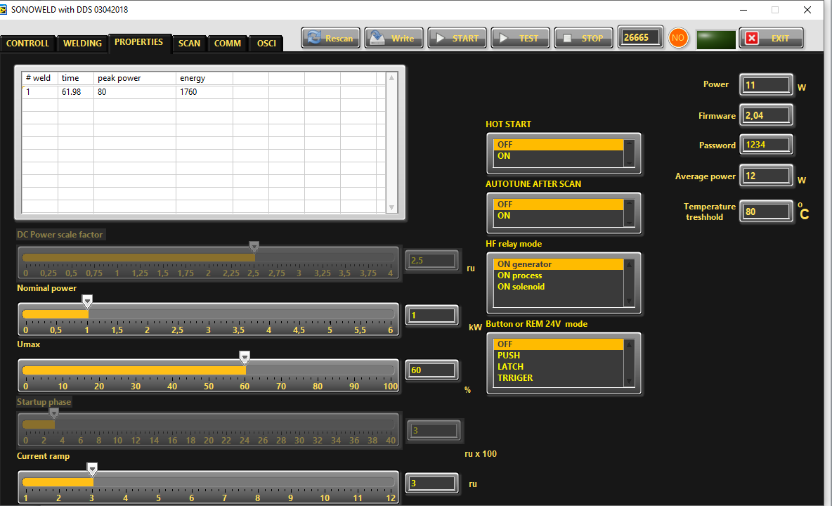

14. Now, your generator and transducer are ready to operate.
15. Start the generator, by pressing button “TEST” .The generator will keep on working until pressing button ”STOP”.
16. Start the Welding cycle, by pressing button “START”.

Current Ramp – This is a type of regulator of the speed of growing of the current, which starts regulating when Imax is close to the set limit in case when the phase set value is still not reached (in ru). When Current Ramp value is small – the current grows fast, when Current Ramp is big – the current grows slow.
Nominal power - The nominal power of the generator(in kWatts).
Umax – the maximum output voltage(in % where 1000V RMS= 100%).
TEMPERATURE TRESHHOLD-External Temperature Limit – setting of the External Temperature Limit (in °C). The generator could generate error signal, when the temperature is over the set limit.
The limit for the External temperature is set in Labview software in PROPERTIES Tab in Temperature Treshold.
PUSH – the button works as a test button – while pushed the generator is on, while released the generator is stopped. See the picture below:
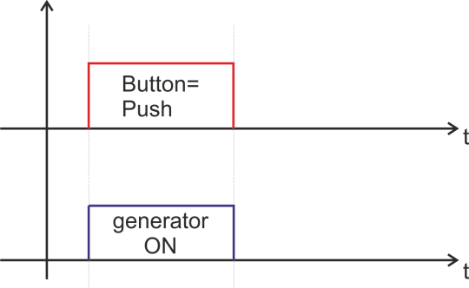
LATCH- pushing the button once the generator starts, pushing the button again the generator stops.
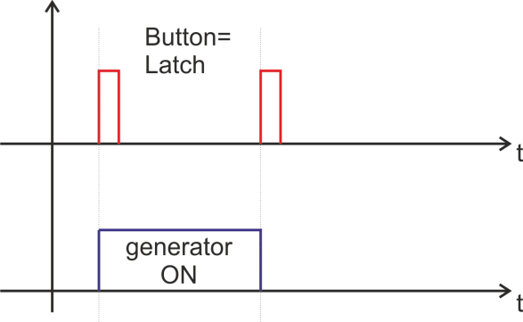

TRIGGER – pushing the button once the welding cycle starts.
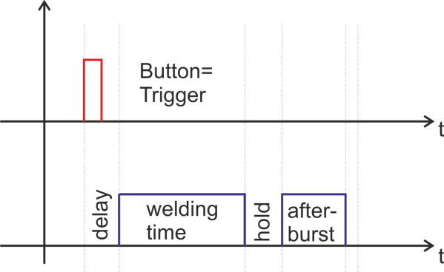

17. Go to

OSCI tab.

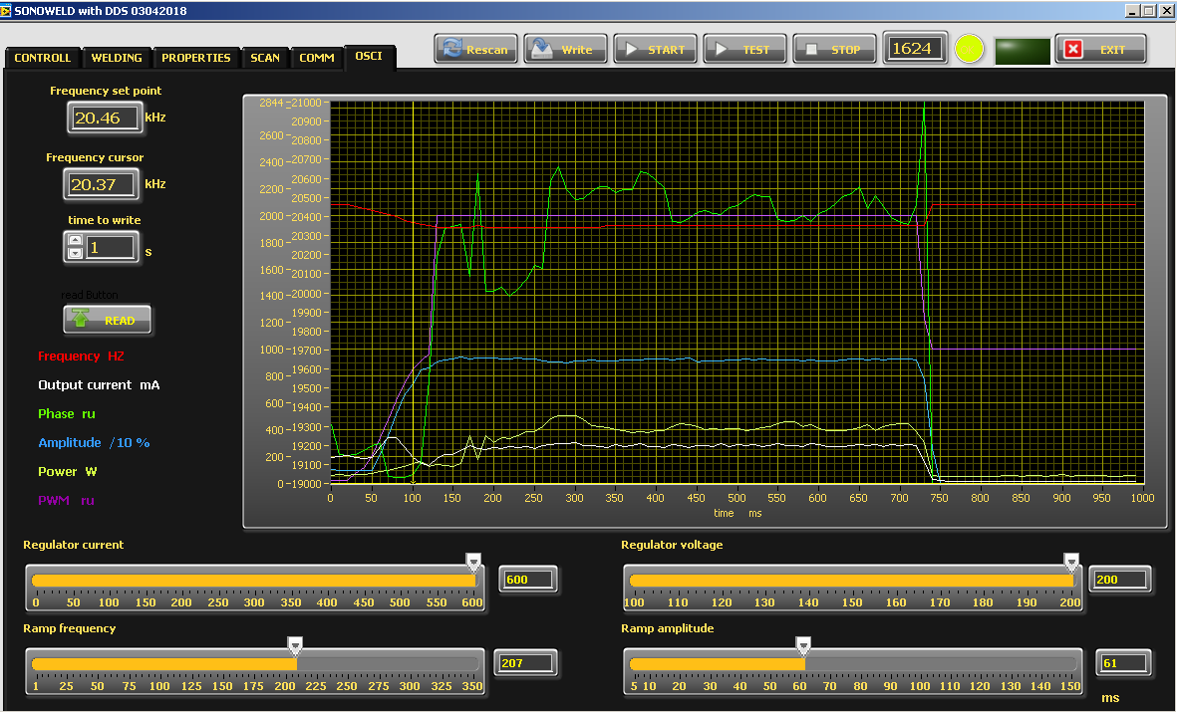

There is an inserted function for recording data – frequency, output current, phase, amplitude and power. Select the duration of the record in the field “time to write” – in seconds. The recording starts by START of the generator and ends when the selected time to write is finished. After recording is finished, when the button read is pressed, the data from generator is uploaded in the Labview software and is visualized graphically.
Regulator voltage – This is the K_{i} of the output voltage regulator(amplitude)
Regulator current - This is the Ki of the output current regulator(amplitude), in case it is selected CURRENT Mode in Regulator Mode Selection Menu.(Phase Mode is the default mode).
Ramp Frequency – This is the ramp that sets the speed of shifting the frequency down- big ramp set value – slow speed, small ramp set value – fast speed.
Ramp Amplitude –This is the ramp that sets the speed of growing the amplitude- big ramp set value – slow speed, small ramp set value – fast speed.
SETTING THE WELDING CYCLE PROPERTIES

1.Go to

WELDING Tab.
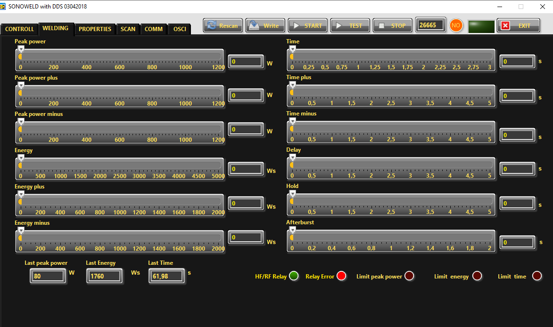

Before setting the welding regime you need to Select TRIGGER Mode for the button – you can do it in PROPERTIES Tab or from the Display.

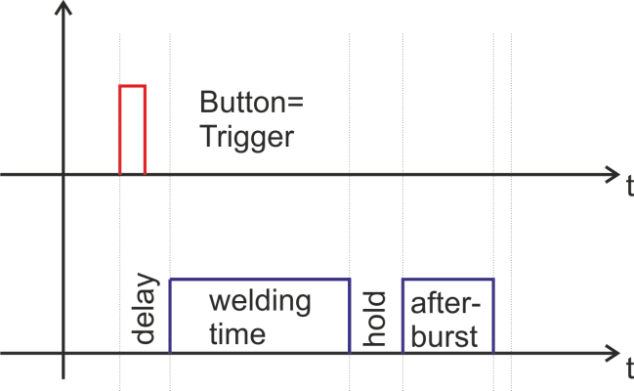

The generator allows carrying out the welding cycle by three criteria:
By TIME - reaching the preset time, the generator stops
When an external start signal(from PLC for examp.) enters on pin 5, pin 17 on the 25-pin DSUB interface socket, the generator starts the programmed welding cycle (as shown on the graphic above).
Welding cycle includes:
Delay – delay after the start signal to turn the generator ON.
Welding time – the generator is ON.
Hold – the generator is OFF for the preset hold time.
Afterburst - the generator is ON for the preset afterburst time.

By ENERGY - reaching the preset energy, the generator stops only the programmed Welding Time (as shown on the graphic above) and keep on to execute hold and afterburst .

By PEAK POWER - reaching the preset peak power, the generator stops only the programmed Welding Time (as shown on the graphic above) and keep on to execute hold and afterburst .

There is an option to set limits for TIME, ENERGY and PEAK POWER or any combination of these 3 criteria.
If there are preset limits for TIME, ENERGY and PEAK POWER together or combination of them, different from zero, the generator will stop after reaching any of the given parameters.
If there are preset limits for TIME, ENERGY and PEAK POWER together or combination of them, equal to zero, the generator will work continuously.

Sliders:
(correspond to the parameters on the display of the generator) :
Welding by time:
Time – time when the generator is on (in seconds)
Time plus – shows the additional safety time. This maximum duration of the control signal (in seconds)
Time minus – minimum duration of the control signal (in seconds)
Note: If entered a control signal from external control unit (PLC) out of limits Time Plus and Time minus, the bicolour LED will light in red and an error message Limit Time will be displayed.
Last time - duration of the last working cycle (in seconds)
Welding by energy:
Energy – setting of nominal energy during the welding process (in Ws). If the setting is different from 0 and the generator reaches the set value the generator automatically stops.
Energy plus – maximum allowed energy reached during the welding process.(in Ws)
Energy minus – minimum allowed energy reached during the welding process (in Ws)

Note: If the energy during the welding process is out of limits Energy Plus and Energy Minus, the bicolour LED will light in red and an error message Limit Energy will be displayed.

Last Energy – energy of the last working cycle (in Ws)
Welding by peak power:
Peak Power – setting of the peak power (in W). If the setting is different from 0 and the generator reaches the set value of the peak power, the generator automatically stops.
Peak plus – maximum allowed peak power reached during the welding process (in W)
Peak minus– minimum allowed peak power reached during the welding process (in W)

Note: If the Peak Power during the welding process is out of limits Peak Plus and Peak minus, the bicolour LED will light in red and an error message Limit Peak Power will be displayed.

Last pk Power – peak power of the last working process (in W)

Delay – after the start signal, the generator delays starting with the set value of the delay (in seconds)
Hold – the generator delays with the set hold value before executing Afterburst (in seconds)
Afterburst – setting the value of afterburst (in seconds)
Last time - time for the last working process (in seconds)

HF-DA RELAY MODE
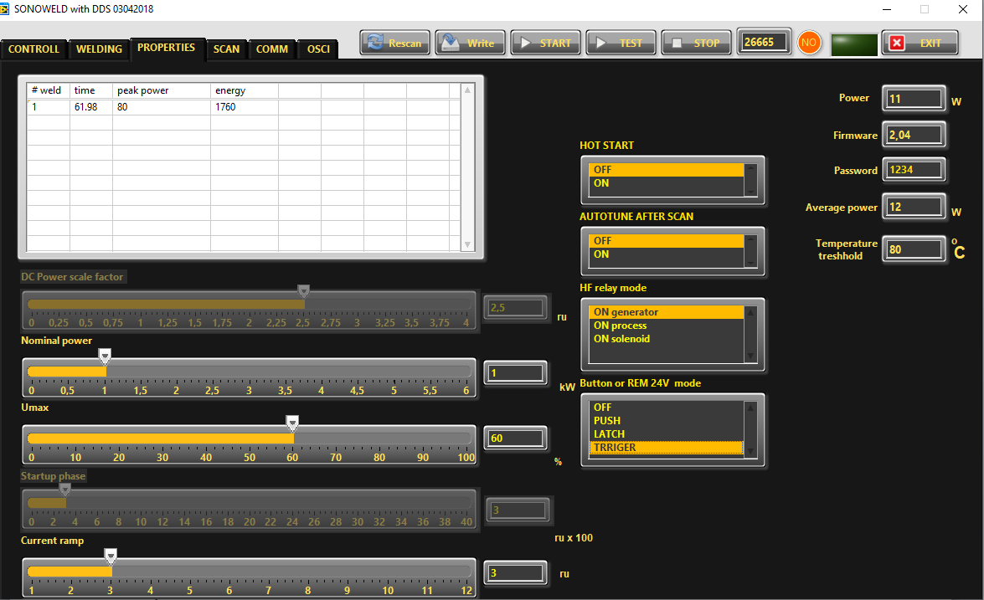

In PROPERTIES Tab you can select the HF Relay Mode(see right bottom corner) from three options:

ON generator – the relay is ON only during welding time.

ON process – the relay is ON during whole process, including delay, welding time, hold and afterburst.

ON solenoid - the relay is ON during delay, welding time and hold together.

ERROR MESSAGES AND TROUBLESHOOTING

When error event occurs the bicolour LED will ligh up in red. The error message will appear over the dynamic bar graph. If you want to see it properly you need to press the rotary encoder once, to move to next window of the display (Power window), where on the last row an error message will be displayed.
All types of error messages will be cleared after restarting the generator.

The following error messages may appear on the display:

OVERCURRENT – Overlimitted high current is flowed through the power transistors

The electronic overcurrent trigger has detected an error.

Possible causes:
· Short circuit in the cable or transducer
· Starting frequency selected is too HIGH
· Starting frequency selected may be too LOW
· There is a problem with the transducer.

Troubleshooting:
· Switch on the generator without the transducer connected. If OVERCURRENT
Message does not appear on the display, this means that the generator is in good working condition.
· Check the cable between the generator and the transducer.
· Check the transducer for short circuit.
· Change and set properly the starting frequency, if it is not in range as described in this manual.

Error message:
OVERHEATING

The electronic overheating trigger has detected an error

Possible causes: · Not enough space around the generator.
· Ambient temperature is too high.
· The fan is dirty or malfunctioning .

Error message:
OVERVOLTAGE -Overlimitted high voltage is applied over the transducer

Possible causes:
· The cable between the generator and transducer is broken or just disconnected.

· Starting frequency selected is too HIGH
· Starting frequency selected may be too LOW
Troubleshooting:
· Rescan and re-adjust the generator as described in this manual

Error message:
LOAD ERROR – the generator cannot find the resonance frequency of the transducer inside the choosen frequency window.

Possible causes:
· Starting frequency selected is too HIGH
· Starting frequency selected may be too LOW – below the resonance frequency
· Span selected may be too LOW
· The cable between the generator and the transducer is broken
· The transducer is defective

Troubleshooting:
· Rescan and re-adjust the generator as described in this manual
· Check the cable between the generator and the transducer.
· Check the transducer for disconnection.

Error message:
FREQUENCY ERROR
Possible causes:
· Bad frequency setting
· Control board is damaged

Troubleshooting:
· Check the frequency settings

LIMIT TIME ERROR
Possible causes:
· Over limit for Time Plus or Time minus has been entered

Troubleshooting:
· Check the Time settings

LIMIT ENERGY ERROR
Possible causes:
· the energy during the welding process is out of limits Energy Plus and Energy Minus,

Troubleshooting:
· Check the Energy settings
· Check the Welding Process for lapses

LIMIT Peak Power ERROR
Possible causes:
· the Peak Power during the welding process is out of limits Peak Plus and Peak minus

Troubleshooting:
· Check the Time settings
· Check the Welding Process for lapses

MAINTENANCE

The ultrasonic generator does not need special maintenance.

Dust and dirt should be removed regularly using a damp cloth.

ATTENTION: • Do not use aggressive cleaners!
• Not suitable for ultrasonic cleaning!

SPECIFICATIONS:

Frequency | SONOROD 2000  65 - 75 kHz
Operating voltage | 230 V +/- 15%
Power consumption | 4.5 A
Effective power output | 1000 W
Maximum output | 2,000 W
Fuse protection | 10 A
Dimension casing | W x H x D/mm/  125x371x252 | Weight  6 kg
Operating Temperature range | -10 to +40°C | Protection class  IP 20, IEC 60 529, EN 60 525

WARRANTY

The length and coverage of the warranty can be found in the terms of delivery as part of the general terms and conditions (valid at the time of purchase) or in the sales contract / order confirmation, should any special agreements have been made.

The following cases are not covered by warranty:

- Damage caused by inappropriate operation
- The device not being used for its intended purpose
- Inappropriate alterations or modifications made without prior authorisation from the manufacturer
- Damage caused by extreme circumstances, such as knocks, falling over, moisture and dirt
- Insufficiently qualified operating staff
- Non-compliance with current safety and accident-prevention regulations
- Damage resulting from modifications made to the operating instructions

SPARE PARTS

Parts are available upon request. Please provide us the serial number of your device, to ensure we supply you with the appropriate replacements.

